Stem cell researcher targets 'seeds' of breast cancer metastasis
July 11, 2014

University of Southern California - Health Sciences

For breast cancer patients, the era of personalized medicine may be just around the corner. Breast cancer cells circulating through the blood streams of six patients have been isolated for study in a recent research project. Some of these deadly cancer cells are the "seeds" of metastasis, which travel to and establish secondary tumors in vital organs such as the bone, lungs, liver and brain.

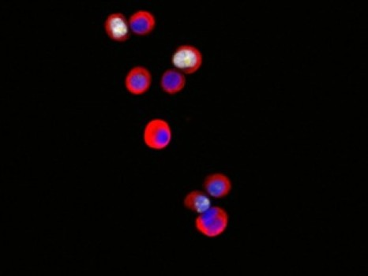
Circulating tumor cells from the blood of a breast cancer patient.
Credit: Image by Maria C. Donaldson and Min Yu
For breast cancer patients, the era of personalized medicine may be just around the corner, thanks to recent advances by USC Stem Cell researcher Min Yu and scientists at Massachusetts General Hospital and Harvard Medical School.
In a July 11 study in Science, Yu and her colleagues report how they isolated breast cancer cells circulating through the blood streams of six patients. Some of these deadly cancer cells are the "seeds" of metastasis, which travel to and establish secondary tumors in vital organs such as the bone, lungs, liver and brain.
Yu and her colleagues managed to expand this small number of cancer cells in the laboratory over a period of more than six months, enabling the identification of new mutations and the evaluation of drug susceptibility.
If perfected, this technique could eventually allow doctors to do the same: use cancer cells isolated from patients' blood to monitor the progression of their diseases, pre-test drugs and personalize treatment plans accordingly.
In the six estrogen receptor-positive breast cancer patients in the study, the scientists found newly acquired mutations in the estrogen receptor gene (ESR1), PIK3CA gene and fibroblast growth factor receptor gene (FGFR2), among others. They then tested either alone or in combination several anticancer drugs that might target tumor cells with these mutations and identified which ones merit further study. In particular, the drug Ganetspib -- also known as STA-9090 -- appeared to be effective in killing tumor cells with the ESR1 mutation.
"Metastasis is the leading cause of cancer-related death," said Yu, assistant professor in the Department of Stem Cell Biology and Regenerative Medicine at the Keck School of Medicine of USC. "By understanding the unique biology of each individual patient's cancer, we can develop targeted drug therapies to slow or even stop their diseases in their tracks."

Pluripotency factor NANOG active in adult organisms

July 9, 2014

Centro Nacional de Investigaciones Oncologicas (CNIO)

NANOG, an essential gene for embryonic stem cells, also regulates cell division in stratified epithelia in adult organisms, researchers have found. According to the conclusions of the study this factor could also play a role in the formation of tumors derived from stratified epithelia of the esophagus and skin.

Scientists from the Spanish National Cancer Research Centre (CNIO) have discovered that NANOG, an essential gene for embryonic stem cells, also regulates cell division in stratified epithelia -- those that form part of the epidermis of the skin or cover the esophagus or the vagina -- in adult organisms. According to the conclusions of the study, published in the journal Nature Communications, this factor could also play a role in the formation of tumours derived from stratified epithelia of the esophagus and skin.
The pluripotency factor NANOG is active during just two days previous to the implantation of the embryo in the uterus (from day 5 to day 7 post-fertilization). At this critical period of development, NANOG contributes to giving embryonic stem cells the extraordinary capacity to make up all of the tissues that become the adult organism, an ability technically known as pluripotency.
Up until now, it was thought that the function of NANOG was limited to the above-mentioned developmental stage immediately prior to implantation. The CNIO study, led by Manuel Serrano and Daniela Piazzolla, however, shows that NANOG also plays a role in the adult organism.
After analysing the presence of NANOG in different mouse tissues by immunohistochemistry, the CNIO team demonstrated that, in addition to being present in embryonic tissue, this factor is also found in stratified epithelia such as the esophagus, skin or vagina.
NANOG Is Linked to Tumours Derived From Stratified Epithelia
Furthermore, the researchers studied a line of mice that can be programmed to induce the NANOG factor over a limited period of time. As described in the article, when NANOG was increased in these mice, the epithelia showed an increase in cellular proliferation, hyperplasia, and an increase in the amount of DNA damage in the cells.
"Interestingly, the effects of NANOG were only observed in stratified epithelia, whereas other tissues, such as the liver of kidney, were completely indifferent to the expression of NANOG," says Serrano. This reinforces the idea that NANOG selectively operates in stratified epithelia.
"Using genome-wide analysis, we demonstrate that this factor is able to specifically regulate cell proliferation in these tissues, and it does it by means of the AURKA protein that is involved in the control of cell division," says Serrano.
The authors of the work also show that NANOG is increased in patient-derived tumour samples from stratified epithelia. Furthermore, when they blocked the action of the gene using RNA interference, the cell proliferation index was reduced.
"This tells us that these cancerous cells depend on NANOG activity to maintain their high proliferation rate and oncological properties," says Serrano.
The study has benefitted from the participation of CNIO researchers Marcos Malumbres and Ignacio Pérez de Castro, who are experts on protein AURKA and its role in the cell cycle. This work has been funded by the Ministry of Economy and Competitiveness, the European Union, the Community of Madrid, the Botín Foundation, the Ramón Areces Foundation, and the AXA Foundation.

Patient-specific stem cells and personalized gene therapy

July 10, 2014

Columbia University Medical Center

Researchers have created a way to develop personalized gene therapies for patients with retinitis pigmentosa, a leading cause of vision loss. The approach, the first of its kind, takes advantage of induced pluripotent stem cell technology to transform skin cells into retinal cells, which are then used as a patient-specific model for disease study and preclinical testing.

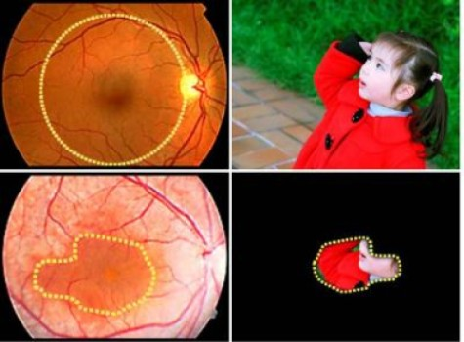
These are images of normal (above) and diseased retinas. Patients with MFRP mutations, a cause of retinitis pigmentosa, lose the function of most retinal cells, particularly at the periphery of the retina, leaving them with drastically reduced vision. Personalized gene therapy, using iPS cells, may offer a way to correct this genetic disorder.
Credit: Lab of Stephen H. Tsang, M.D., Ph.D./Columbia University Medical Center
Columbia University Medical Center (CUMC) researchers have created a way to develop personalized gene therapies for patients with retinitis pigmentosa (RP), a leading cause of vision loss. The approach, the first of its kind, takes advantage of induced pluripotent stem (iPS) cell technology to transform skin cells into retinal cells, which are then used as a patient-specific model for disease study and preclinical testing.
Using this approach, researchers led by Stephen H. Tsang, MD, PhD, showed that a form of RP caused by mutations to the gene MFRP (membrane frizzled-related protein) disrupts the protein that gives retinal cells their structural integrity. They also showed that the effects of these mutations can be reversed with gene therapy. The approach could potentially be used to create personalized therapies for other forms of RP, as well as other genetic diseases. The paper was published recently in the online edition ofMolecular Therapy, the official journal of the American Society for Gene & Cell Therapy.
"The use of patient-specific cell lines for testing the efficacy of gene therapy to precisely correct a patient's genetic deficiency provides yet another tool for advancing the field of personalized medicine," said Dr. Tsang, the Laszlo Z. Bito Associate Professor of Ophthalmology and associate professor of pathology and cell biology.
While RP can begin during infancy, the first symptoms typically emerge in early adulthood, starting with night blindness. As the disease progresses, affected individuals lose peripheral vision. In later stages, RP destroys photoreceptors in the macula, which is responsible for fine central vision. RP is estimated to affect at least 75,000 people in the United States and 1.5 million worldwide.
More than 60 different genes have been linked to RP, making it difficult to develop models to study the disease. Animal models, though useful, have significant limitations because of interspecies differences. Researchers also use human retinal cells from eye banks to study RP. As these cells reflect the end stage of the disease process, however, they reveal little about how the disease develops. There are no human tissue culture models of RP, as it would dangerous to harvest retinal cells from patients. Finally, human embryonic stem cells could be useful in RP research, but they are fraught with ethical, legal, and technical issues.
The use of iPS technology offers a way around these limitations and concerns. Researchers can induce the patient's own skin cells to revert to a more basic, embryonic stem cell-like state. Such cells are "pluripotent," meaning that they can be transformed into specialized cells of various types.
In the current study, the CUMC team used iPS technology to transform skin cells taken from two RP patients -- each with a different MFRP mutation -- into retinal cells, creating patient-specific models for studying the disease and testing potential therapies.
By analyzing these cells, the researchers found that the primary effect of MFRP mutations is to disrupt the regulation of actin, the protein that makes up the cytoskeleton, the scaffolding that gives the cell its structural integrity. "Normally, the cytoskeleton looks like a series of connected hexagons," said Dr. Tsang. "If a cell loses this structure, it loses its ability to function."
The researchers also found that MFRP works in tandem with another gene, CTRP5, and that a balance between the two genes is required for normal actin regulation.
In the next phase of the study, the CUMC team used adeno-associated viruses (AAVs) to introduce normal copies of MFRP into the iPS-derived retinal cells, successfully restoring the cells' function. The researchers also used gene therapy to "rescue" mice with RP due to MFRP mutations. According to Dr. Tsang, the mice showed long-term improvement in visual function and restoration of photoreceptor numbers.
"This study provides both in vitro and in vivo evidence that vision loss caused by MFRP mutations could potentially be treated through AAV gene therapy," said coauthor Dieter Egli, PhD, an assistant professor of developmental cell biology (in pediatrics) at CUMC, who is also affiliated with the New York Stem Cell Foundation.
Dr. Tsang thinks this approach could also be used to study other forms of RP. "Through genome-sequencing studies, hundreds of novel genetic spelling mistakes have been associated with RP," he said. "But until now, we've had very few ways to find out whether these actually cause the disease. In principle, iPS cells can help us determine whether these genes do, in fact, cause RP, understand their function, and, ultimately, develop personalized treatments."

No extra mutations in modified stem cells, study finds

July 9, 2014

Salk Institute for Biological Studies

The ability to switch out one gene for another in a line of living stem cells has only crossed from science fiction to reality within this decade. As with any new technology, it brings with it both promise -- the hope of fixing disease-causing genes in humans, for example -- as well as questions and safety concerns. Now, scientists have put one of those concerns to rest: using gene-editing techniques on stem cells doesn't increase the overall occurrence of mutations in the cells.

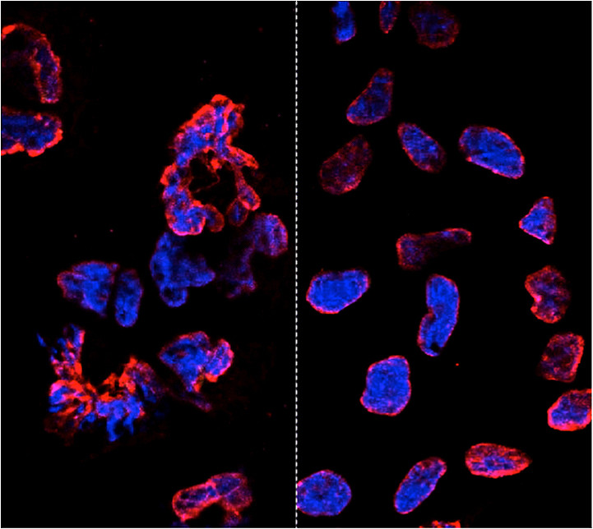
The new study shows that gene-editing technologies are specific to their targets and do not introduce harmful mutations, clearing the way for the development of safe therapies in the clinic. The left panel shows misshapen nuclear envelopes (red) from induced pluripotent stem cells derived from cells with Parkinson’s disease (DNA in blue). The right panel shows similarly induced cells that have been gene-edited to restore the cells.
Credit: The Salk Institute for Biological Studies
The ability to switch out one gene for another in a line of living stem cells has only crossed from science fiction to reality within this decade. As with any new technology, it brings with it both promise--the hope of fixing disease-causing genes in humans, for example--as well as questions and safety concerns. Now, Salk scientists have put one of those concerns to rest: using gene-editing techniques on stem cells doesn't increase the overall occurrence of mutations in the cells. The new results were published July 3 in the journal Cell Stem Cell.
"The ability to precisely modify the DNA of stem cells has greatly accelerated research on human diseases and cell therapy," says senior author Juan Carlos Izpisua Belmonte, professor in Salk's Gene Expression Laboratory. "To successfully translate this technology into the clinic, we first need to scrutinize the safety of these modified stem cells, such as their genome stability and mutational load."
When scientists want to change the sequence of a stretch of DNA inside cells--either for research purposes or to fix a genetic mutation for therapeutic purposes--they have their choice of two methods. They can use an engineered virus to deliver the new gene to a cell; the cell then integrates the new DNA sequence in place of the old one. Or scientists can use what's known as custom targeted nucleases, such as TALEN proteins, which cut DNA at any desired location. Researchers can use the proteins to cut a gene they want to replace, then add a new gene to the mix. The cell's natural repair mechanisms will paste the new gene in place.
Previously, Belmonte's lab had pioneered the use of modified viruses, called helper-dependent adenoviral vectors (HDAdVs) to correct the gene mutation that causes sickle cell disease, one of the most severe blood diseases in the world. He and his collaborators used HDAdVs to replace the mutated gene in a line of stem cells with a mutant-free version, creating stem cells that could theoretically be infused into patients' bone marrow so that their bodies create healthy blood cells.
Before such technologies are applied to humans, though, researchers like Belmonte wanted to know whether there were risks of editing the genes in stem cells. Even though both common gene-editing techniques have been shown to be accurate at altering the right stretch of DNA, scientists worried that the process could make the cells more unstable and prone to mutations in unrelated genes--such as those that could cause cancer.
"As cells are being reprogrammed into stem cells, they tend to accumulate many mutations," says Mo Li, a postdoctoral fellow in Belmonte's lab and an author of the new paper. "So people naturally worry that any process you perform with these cells in vitro--including gene editing--might generate even more mutations."
To find out whether this was the case, Belmonte's group, in collaboration with BGI and the Institute of Biophysics, Chinese Academy of Sciences in China, turned to a line of stem cells containing the mutated gene that causes sickle cell disease. They edited the genes of some cells using one of two HDAdV designs, edited others using one of two TALEN proteins, and kept the rest of the cells in culture without editing them. Then, they fully sequenced the entire genome of each cell from the four edits and control experiment.
While all of the cells gained a low level of random gene mutations during the experiments, the cells that had undergone gene-editing--whether through HDAdV- or TALEN-based approaches--had no more mutations than the cells kept in culture.
"We were pleasantly surprised by the results," Keiichiro Suzuki, a postdoctoral fellow in Belmonte's lab and an author of the study, says. "People have found thousands of mutations introduced during iPSC reprogramming. We found less than a hundred single nucleotide variants in all cases."
The finding, Li adds, doesn't necessarily mean that there are no inherent risks to using stem cells with edited genes, but that the editing process doesn't make the stem cells any less safe.
"We concluded that the risk of mutation isn't inherently connected to gene editing," he says. "These cells present the same risks as using any other cells manipulated for cell or gene therapy." He adds that two other papers published in the same issue support their results (one by Johns Hopkins University and one from Harvard University and collaborators).
The Belmonte group is planning more studies to address whether gene-repair in other cell types, using other approaches, or targeting other genes could be more or less likely to cause unwanted mutations. For now, they hope their findings encourage those in the field to keep pursuing gene-editing techniques as a potential way to treat genetic diseases in the future.
Other researchers on the study were Jing Qu, April Goebl, Emi Aizawa, Rupa Devi Soligalla, Jessica Kim, Na Young Kim, Hsin-Kai Liao, Chris Benner, and Concepcion Rodriguez Esteban of the Salk Institute for Biological Studies; Chang Yu, Xiaotian Yao, Senwei Tang, Fan Zhang, Feng Chen, Yabin Jin, and Yingrui Li of BGI; and Jing Qu,Tingting Yuan, Ruotong Ren, Xiuling Xu, and Guang-Hui Liu of the Institute of Biophysics, Chinese Academy of Sciences.
The work was supported by the G. Harold and Leila Y. Mathers Charitable Foundation, the Leona M. and Harry B. Helmsley Charitable Trust, the Glenn Foundation, the California Institute of Regenerative Medicine, the National Institutes of Health, the Chinese Academy of Sciences, the Beijing Natural Science Foundation, and the Thousand Young Talents program of China.

